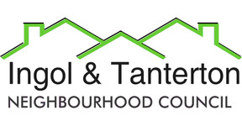

**52 Bowlingfield**

**Dovehaven Lodge**

**Tanterton Village Centre**

**11 Mason House Crescent**

**Ashbourne Day Nurseries**

**Pool House Primary**

**2 Greenfield Way**

**132 Whitby Ave**

**28 Dunoon Close**

**316 Tag Lane**

**141 Hargreaves Court**

**71 Dovedale Close**

**Ingol Methodist Church**

**Dovedale Court Care Home**

**Intact**

**290 Tag Lane**

**55 Dunoon Close**

**Ingol Library**

**Ingol Community Primary School**

**259/261 Tag Lane**

**5 & 7 Cottam Avenue**

**Ingol Dip**

**195 Tag Ln**

**23 Cottam Ave**

**20 Clevedon Rd**

**28 & 30 Westbrook Crescent**

**22 Hillcrest Ave**

**36 Creswell Ave**

**Lady Elsie Finney House**